Operator Sign Up Instructions
These must be followed correctly. If not, your account will not work.

- Open the invitation email.
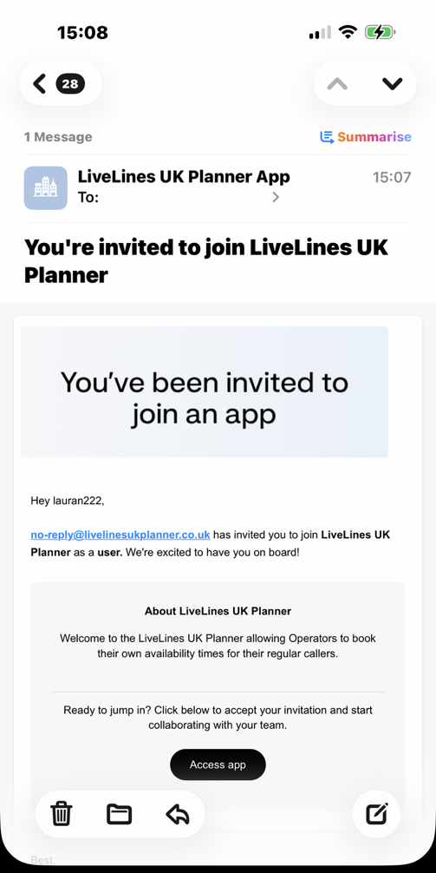

- Click on the “Sign up” link.
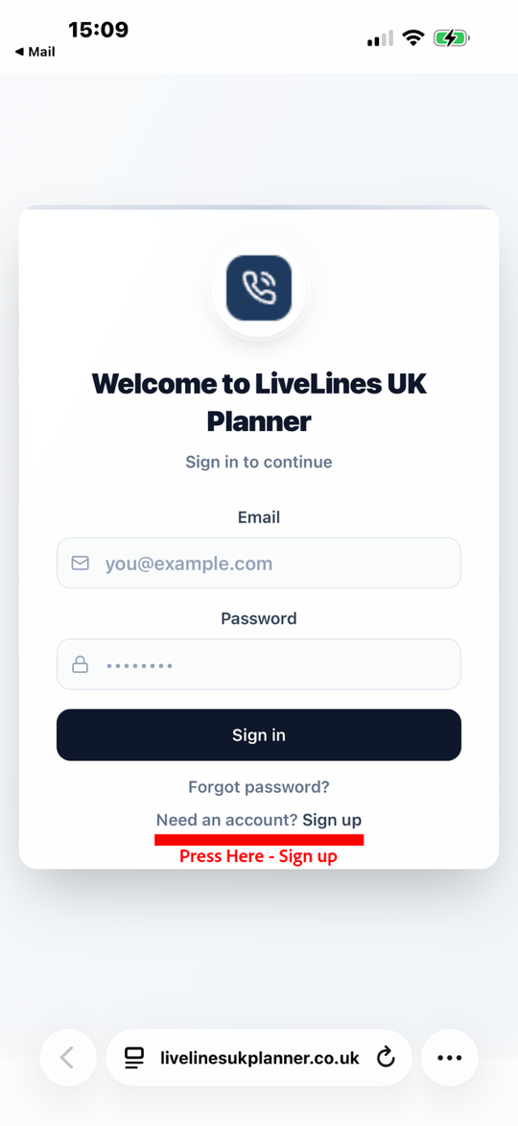

- Enter the same email address we sent the invitation to. If you use a different email address, your account will not work. Then set your password.

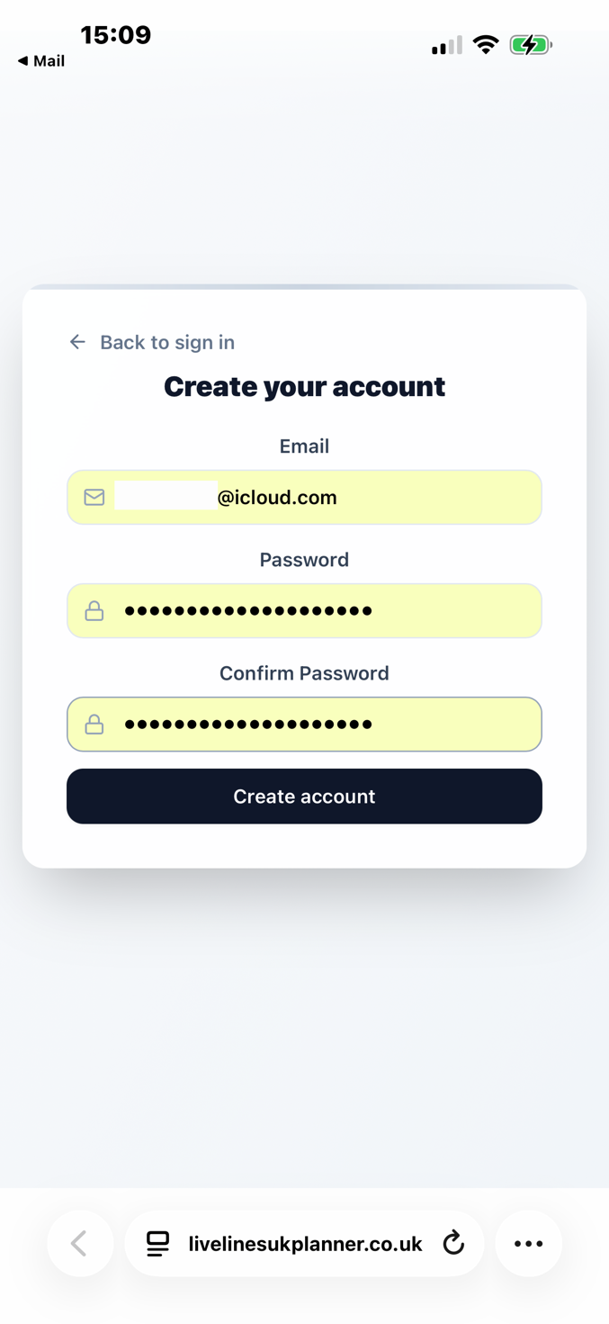

- You’ll then be sent an email with a verification code. You MUST enter this code.

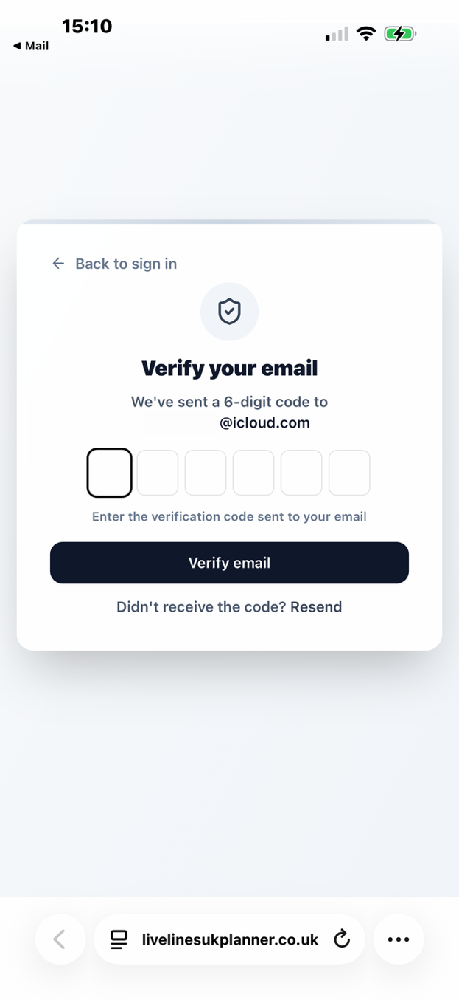

- You’ll then be given access to the block booker.
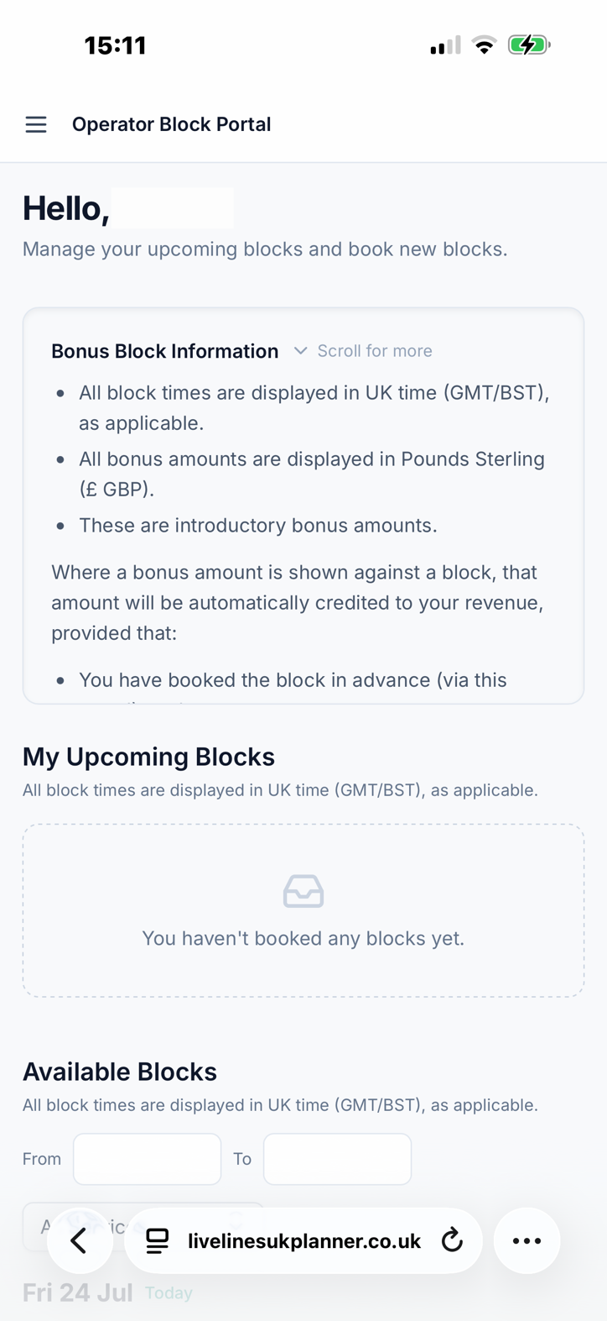
Please note:
When setting your password, you MUST use the same email address we sent your invitation email to. Point 3.
You MUST verify the email by entering the code sent to you in an email. Point 4.
If the process is not followed, the account will not work. You will have to contact us at support@livelinesuk.com so we can delete your setup and start again with a new invitation.

